5.19: Denote the scale reading as F, and take positive directions to be upward. Then,
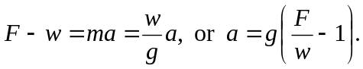
a) , down.
b) up. c) If 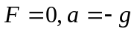 and the student, scale, and elevator are in free fall. The student should worry.

